**EXPERIMENT NO. 04**

**TO MEASURE ATTENUATION IN OPTICAL FIBER**

**EXPERIMENT NO. 04**

**TO MEASURE ATTENUATION IN OPTICAL FIBER**

**OBJECTIVE:**

To Study the length dependence of attenuation in the given optical fiber.

**EQUIPMENT:**

1. C Band Lasers -1
2. Laser – 850 nm
3. InGaAsPhotodetector – 1
4. Si Photodetector (PD5) -1
5. Fiber Spools

**FORMULA USED:**

If Pi represent the input power and P2 is the output power after passing through an optical fiber of length L km,

Attenuation,

Attenuation coefficient,

**THEORY:**

Attenuation is a very important property of any optical fiber and decides the maximum distance that the light wave can propagate and still be detectable at the output by a receiver. Attenuation is a function of wavelength and the minimum attenuation of silica optical fibers occurs at a wavelength of 1550 nm. Typically optical fiber loss is found to be in range of 0.20 to 0.30 dB/km at 1550 nm and therefore even after propagating through 80 km of such a fiber, the output would be 1 % of the input power.

The loss in an optical fiber is measured in logarithmic units of decibels per kilometer

(dB/km) and is defined by the following equation,

Where P(0) is the optical power at the input (z=0) and P(L) is the optical power at the output, i.e. L km away from the input end. Here we assume z to be the direction along the length of the optical fiber.

**PROCEDURE:**

1. Setup the LIGHT RUNNER.
2. Select the corresponding experiment from the experiment drop down menu with the help of stylus and the experiment window will appear on the screen.
3. Connect 850 nm laser source to the photo detector PD5 with the help of patch cords.
4. Connect the BNC connector adjacent to PD5 to anyone channel (say CH1) of the DSO with the help of BNC cable.
5. Enable the 850 nm laser by using stylus and set the following parameters: For example – (a) Frequency = 50 KHz
   1. Duty cycle = 20%
   2. Laser power = 60 %
6. Click on the ‘start’ button, waveform will appear at CH1 on the DSO screen.
7. In case of detector saturation, reduce the laser power level below the saturation level by using software control.
8. After adjusting the power level below the saturation level, note down the optical power displaying in front of the label PD5 as P1.
9. Stop the experiment by clicking on the ‘STOP’ button.
10. Disconnect the patch cord from the detector (PD5) and connect this end to the fiber spools of known length (L).
11. Connect the other end of the fiber spool to the photo detector PD5 by using a patch cord (refer the connections shown below).

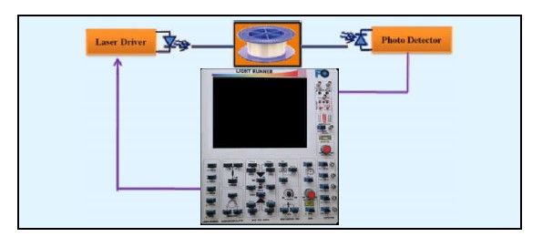

**Fig: Schematic of the setup to determine attenuation of fiber as a function of length and wavelength**

1. Run the experiment by clicking on the ‘Start’ button.
2. Note down the output power, displaying in front of PD5 as P2.
3. From the above measured values, calculate the values of attenuation coefficient and total attenuation at 850 nm wavelength.
4. Repeat the experiment for any of the C-band lasers with respective detector for different length of the fiber spools.
5. In the procedure given here instead of cutback method, the power exiting at a short length and a long length is measured.
6. Since an additional fiber of length L has been introduced in the fiber path, the loss at the extra connector (assumed to be 0.5 dB) should be taken care of in the estimation of attenuation coefficient.
7. Similarly each extra connector in the experiment adds 0.5 dB loss to the measurement.

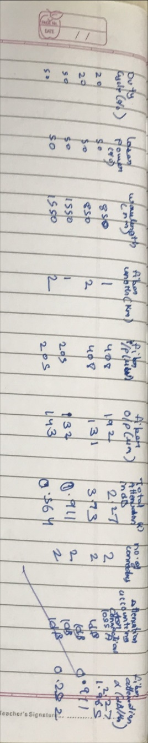**OBSERVATION:**

|  |  |  |  |  |  |  |  |
| --- | --- | --- | --- | --- | --- | --- | --- |
| Wave  lengt h (nm) | Fiber  Length,  L (km) | Fiber  Input  Power,  P1  (mW) | Fiber  Output  Power,  P2  (mW) | Total Attenuatio n A, in  dB=10log(  p1/P2) | Num  ber of connectors | Attenuation after accounting for connector loss, A (db) | Fiber attenuatio n coefficient  , α in dB per km |
| 850 | 1 | 408 | 192 | 2.27 | 2 | 1 | 2.27 |
| 850 | 2 | 408 | 131 | 3.93 | 2 | 1 | 1.965 |
| 1550 | 1 | 205 | 132 | 0.911 | 2 | 1 | 0.911 |
| 1550 | 2 | 205 | 143 | 0.564 | 2 | 1 | 0.282 |

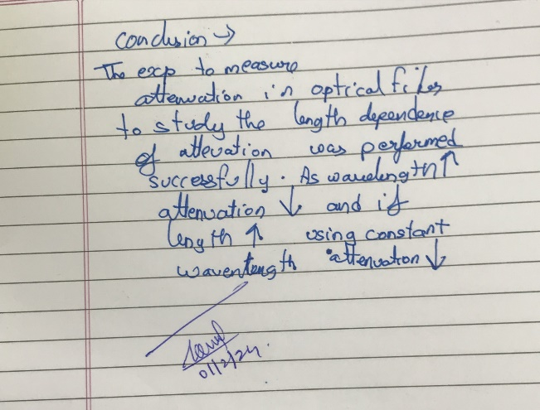**CONCLUSION:**